CS110: Fundamentals of Computer Programming
Class: BSCS-E
Lab 06: Repetition Control Structures – Loops
NAME : Bakhtawar Munir
CMS_ID : 588984
LAB INSTRUCTOR : Ms. Wardah Nisar

2026

Lab Tasks:

Task 1 [CLO 2]: Number-Guessing with a Counter

Write a C++ program that prompts the user to guess a number between 1 to 10. You must store the secret number in a variable and use that variable throughout for checks and count the number of tries it takes the user to guess it. The user will try to guess the secret number until they get it right. That means it will keep looping as long as the guess is different from the secret number. Use while loop to solve this problem.
CODE:
#include <iostream>
using namespace std;

int main() {
int secret_number = 6;
int tries = 0;
int guess_number;
cout<<"I have guessed a number between 1 and 10. Try to guess it."<<endl ;

while (guess_number!=secret_number){
cout << "your guess=";
cin >> guess_number;
tries=tries+1;}
if (guess_number!=secret_number)
cout<<"That is incorrect.Guess again"<<endl;
else
cout<< "That's right you guessed it"<<endl;
cout << "It only took you "<< tries << " tries" <<endl;
return 0;
}
OUTPUT :
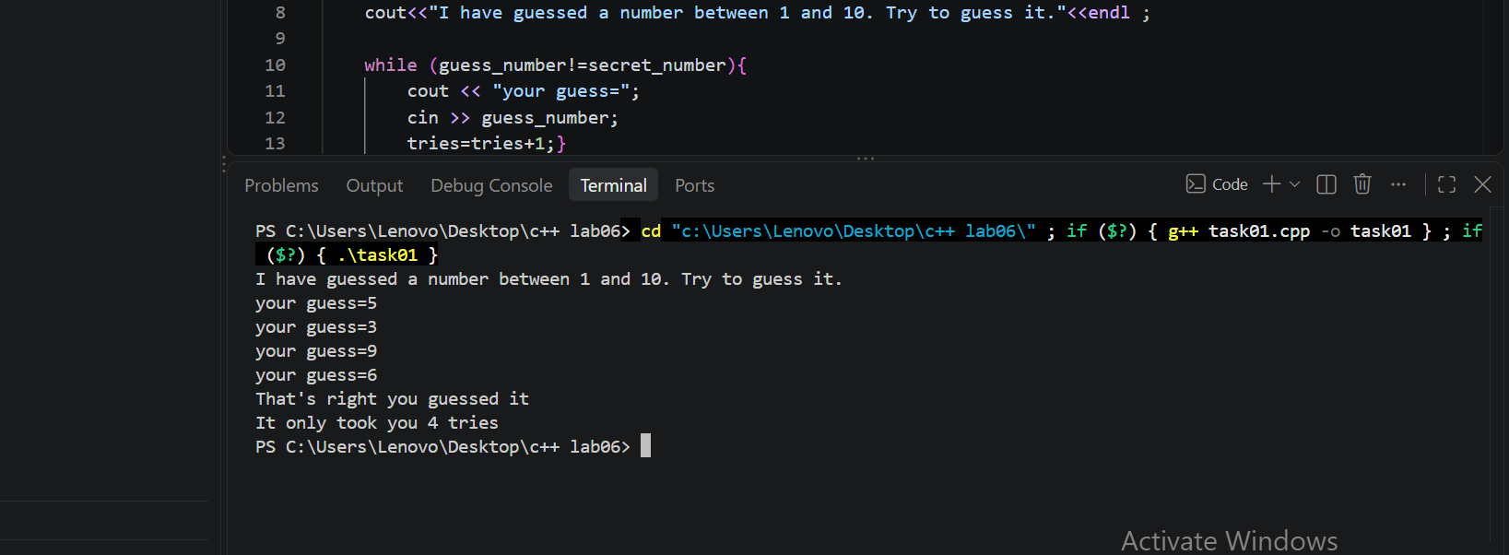

Task 2 [CLO 2]: Computing Harmonic Mean
The harmonic mean is another way of calculating a mean for a set of numbers. The harmonic mean of a set of numbers is given by the equation:

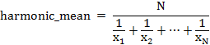

Write a C++ program that prompts the user to enter the value of N (e.g. N = 10) and calculates the harmonic mean of the set of N numbers using do-while loop. Test your program’s output for N=10 and N=4.
CODE :
#include <iostream>
using namespace std;

int main() {
int N;
double sum = 0;
double x;
int count = 1;
cout <<"Enter a positve value of N:";
cin >> N;
do {
cout << "Enter number " << count << ": ";
cin >> x;
sum =sum+(1 / x);
count = count+1;
} while (count <= N);
double harmonic_mean = N / sum;
cout << "Harmonic mean of the "<< N <<" numbers is: " << harmonic_mean ;
return 0;
}
OUTPUT :
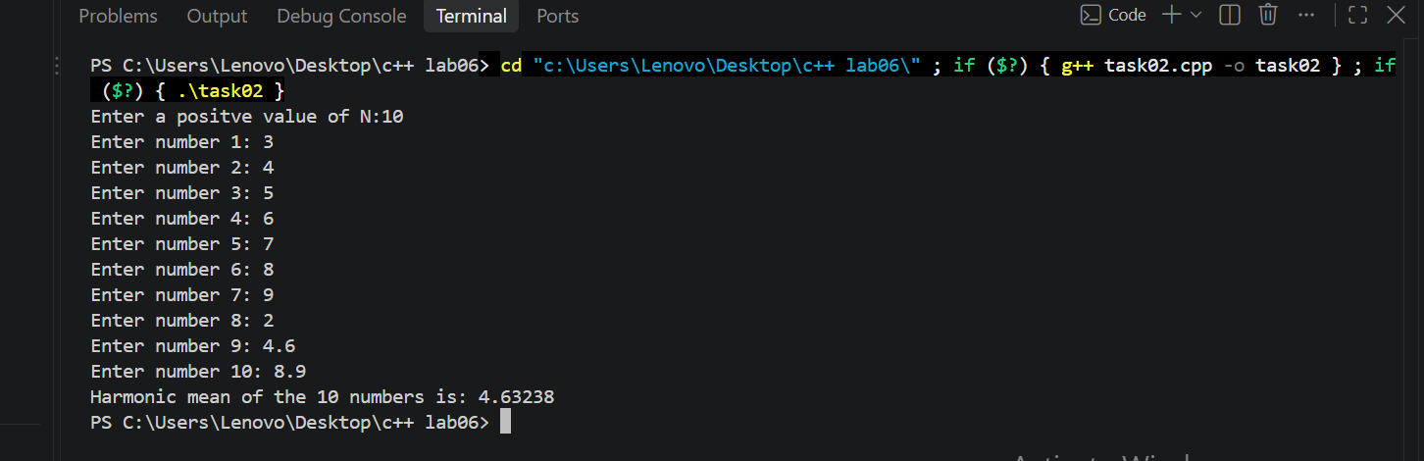
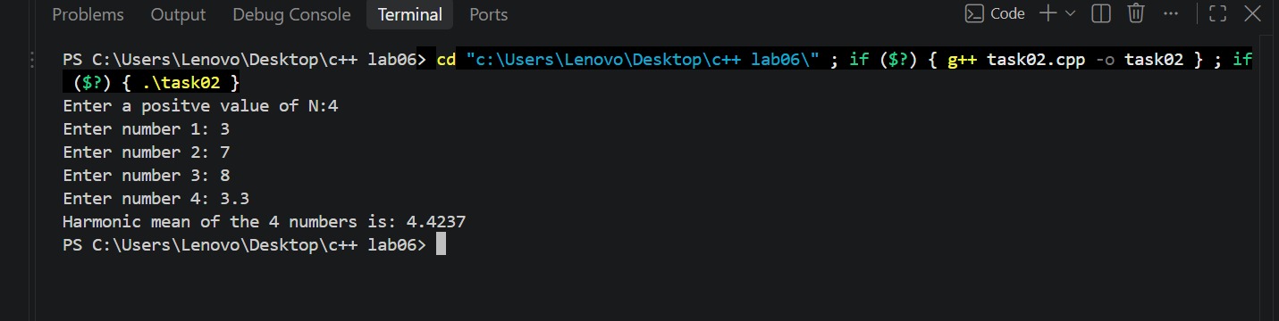

Task 3 [CLO 2]: Finding Factorial of a Number
The factorial of an integer N, written N! is simply the product of all the integers from 1 to n. For example, 5! = 1*2*3*4*5 = 120. Write a C++ program using for-loop to calculate the factorial of an integer N taken input from the user.
CODE :
#include <iostream>
using namespace std ;

int main () {
int N;
cout << "Enter a positive number :" ;
cin >> N;
int fact=1;
for (int i=1;i<=N;i++){
fact= (fact*i) ; }

cout << "The factorial of " << N << " is " << fact ;
return 0;
}
OUTPUT :
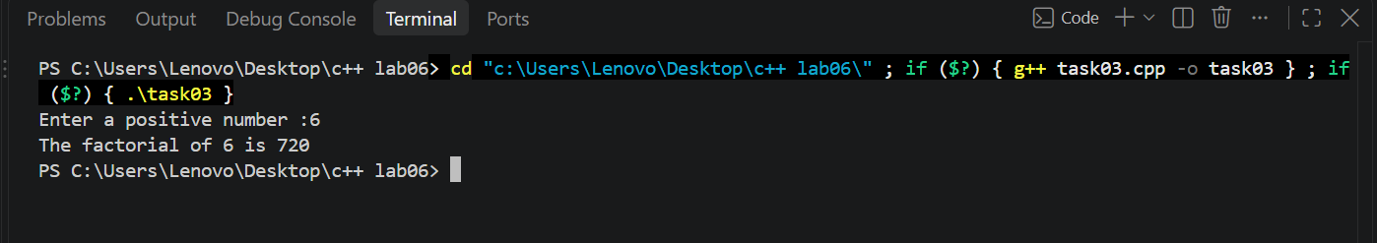

Task 4 [CLO 2]: Finding Lowest Value
Write a C++ program that prompts the user to enter the number of items and each item’s name and price and finally displays the name and price of the item with the lowest price. Use do-while loop to attempt this task.
CODE :
#include <iostream>
using namespace std;
int main () {
int Num_of_items;
cout<<"Enter number of items : ";
cin >> Num_of_items;
string item_name;
float item_price;
string lowest_name;
float lowest_price;
int i =1;
do {
cout<<"Enter item name :";
cin >> item_name;
cout << "Enter item price : ";
cin >> item_price ;
if (i==1) {
lowest_price=item_price;
lowest_name=item_name; }
else if (item_price<lowest_price) {
lowest_price=item_price;
lowest_name=item_name;}
i=i+1;
} while (i<=Num_of_items);
cout<<"Item with the lowest price :" <<endl;
cout << " Item Name : " << lowest_name<<endl;
cout << " Item Price : " << lowest_price <<endl;
return 0;
}
OUTPUT :
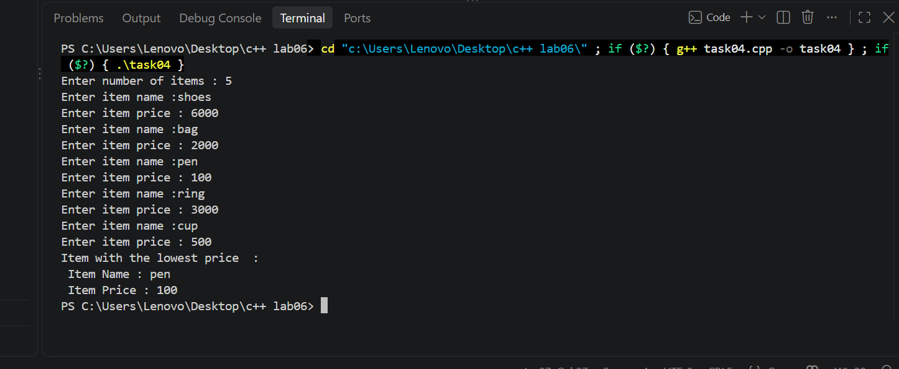

Task 5 [CLO 1]: Using Nested Loops
Use nested for loops to generate all possible coordinates from (0,0) up to (5,5). Your output must appear in rows and columns as follows. Use escape sequences to format your output as given below:

CODE :
#include <iostream>
using namespace std;
int main (){

for (int i=0 ; i<=5 ; i++) {

for (int j=0 ; j<=5 ; j++) {

cout << "("<<i<<","<<j<<")\t"; }
cout << endl; }
return 0;
}
OUTPUT :
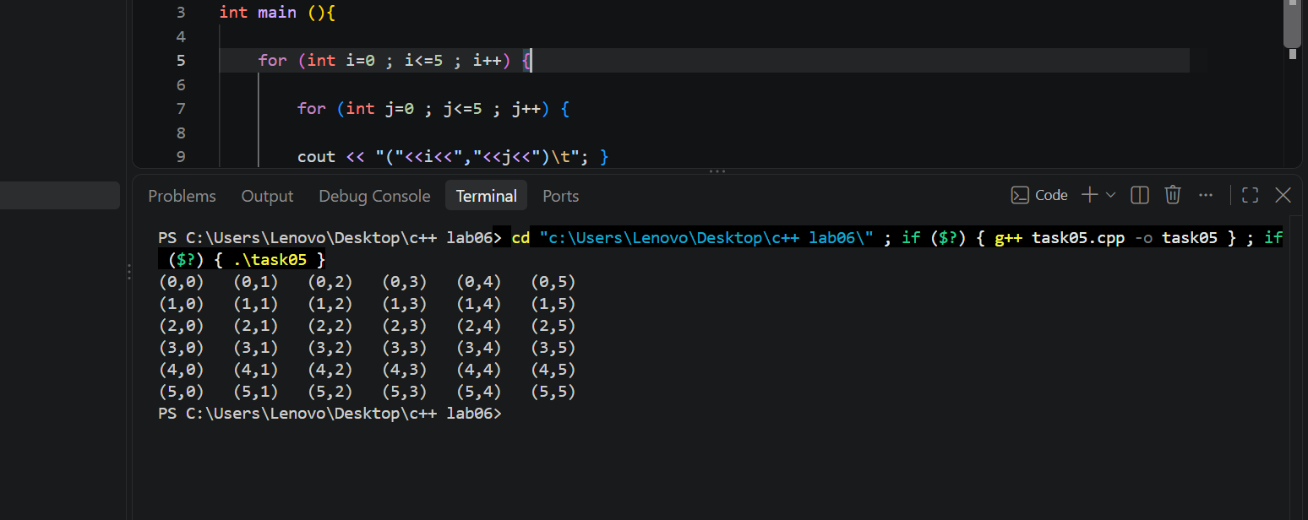

Task 6 [CLO 1]: Using Nested Loops
Use nested for loops to generate the following patterns:
CODE :
A) #include <iostream>
using namespace std;

int main() {
for (int i=1 ; i <= 6; i++) {
for (int j=1; j<=6; j++) {
if (i==1 || i==6 ||j == 1||j == 6)
cout << j;
else
cout << " ";
}
cout << endl;
}
return 0;
}
OUTPUT :
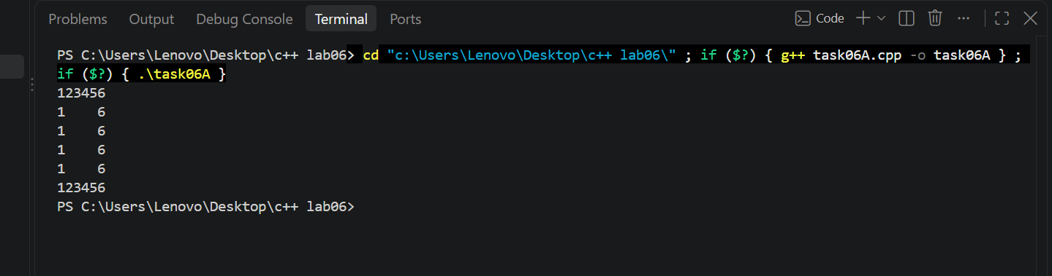
CODE :
B) #include <iostream>
using namespace std;
int main() {
for (int i = 1; i <= 5; i++) {
for (int s = 1; s <= 5 - i; s++)
cout << " ";
for (int j = 1; j <= 2 * i - 1; j++)
cout << j << " ";
cout << endl;
}
return 0;
}
OUTPUT :
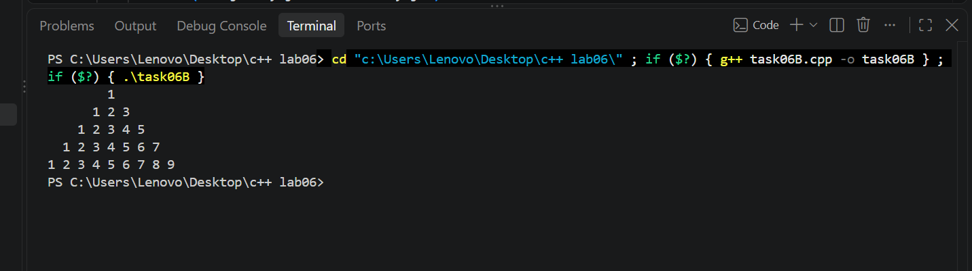
CODE :
C) #include <iostream>
using namespace std;
int main() {
for (int i = 1; i <= 5; i++) {
int count = (i <= 3) ? i : 6 - i;
for (int s = 1; s <= 3 - count; s++)
cout << " ";
for (int j= 1; j <= count; j++)
cout << "3 ";
cout << endl;
}
return 0;
}
OUTPUT :
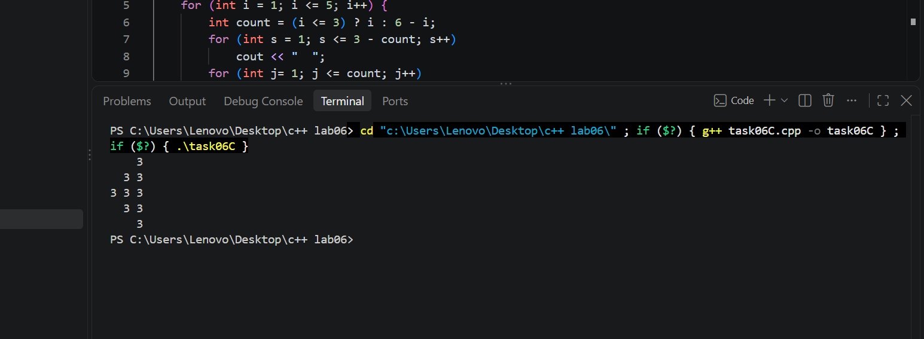

CODE :
D) #include <iostream>
using namespace std;

int main() {
for (int i = 1; i <= 6; i++) {
for (int s = 1; s <= 6 - i; s++)
cout << " ";
for (int j = 1; j <= i; j++)
cout << j << " ";
cout << endl;
}
return 0;
}
OUTPUT :
